California Hospital Inpatient Mortality Rates and Quality Ratings

**State**

The dataset contains risk-adjusted mortality rates, quality ratings, and number of deaths and cases for 6 medical conditions treated (Acute Stroke, Acute Myocardial Infarction, Heart Failure, Gastrointestinal Hemorrhage, Hip Fracture and Pneumonia) and 5 procedures performed (Abdominal Aortic Aneurysm Repair, Unruptured/Open, Abdominal Aortic Aneurysm Repair, Unruptured/Endovascular, Carotid Endarterectomy, Pancreatic Resection, Percutaneous Coronary Intervention) in California hospitals. The 2022 IMIs were generated using AHRQ Version 2023, while previous years' IMIs were generated with older versions of AHRQ software (2021 IMIs by Version 2022, 2020 IMIs by Version 2021, 2019 IMIs by Version 2020, 2016-2018 IMIs by Version 2019, 2014 and 2015 IMIs by Version 5.0, and 2012 and 2013 IMIs by Version 4.5). The differences in the statistical method employed and inclusion and exclusion criteria using different versions can lead to different results. Users should not compare trends of mortality rates over time. However, many hospitals showed consistent performance over years; “better” performing hospitals may perform better and “worse” performing hospitals may perform worse consistently across years. This dataset does not include conditions treated or procedures performed in outpatient settings. Please refer to statewide table for

Link: <https://healthdata.gov/State/California-Hospital-Inpatient-Mortality-Rates-and-/rzs9-tpdk/about_data>

Acute Stroke Subarachnoid and Acute Stroke Hemorrhagic caused the most mortality rate from 2016 to 2022 in California

California Hospital Inpatient Care Quality

**Project need**

Arising from the increasing trend of the five most common health condition (Acute Stroke, Acute Myocardial Infarction, Heart Failure, Gastrointestinal Hemorrhage, Hip Fracture and Pneumonia) and six 5 procedures performed (Abdominal Aortic Aneurysm Repair, Unruptured/Open, Abdominal Aortic Aneurysm Repair, Unruptured/Endovascular, Carotid Endarterectomy, Pancreatic Resection, Percutaneous Coronary Intervention), California Healthcare Foundation is conducting a research on how effective those conditions/ procedure treated in Californian hospitals. Then it will provide a general view on how California performed within the last ten years.

**Dataset**

This project was conducted on a trustable dataset downloaded from HealthData.Gov. This dataset includes 639,194 data rows and 12 columns that indicates the year, county, hospital information, rating, number of conditions/ procedures, and number of deaths. The time frame of this project falls within 2016 and 2022 as data for 2023 and 2024 is not yet available.

Dataset link: <https://healthdata.gov/State/California-Hospital-Inpatient-Mortality-Rates-and-/rzs9-tpdk/about_data>

**Main tools for this project:**

In this project, I utilized Excel data manipulation tools including most common used aggregate functions, Pivot Table method and Pivot Table Charts.

**Key Takeaways from this project:**

* Conditions/ procedures and death cases significantly had decreased from 2020 to 2022.
* Heart failure and acute stroke are the most two common conditions across the observing years.
* Los Angeles appears to have the most significant death rate.
* Acute stroke and pneumonia are the most causes of death.
* Centinela Hospital Medical Center was rated the best hospital in the investigating years.
* Mercy Medical Center Redding has the highest rating of “Worse”.

**Analysis**

**Overall trend of conditions/procedures vs death**

In this analysis, I employed the Pivot Table of Year, Sum of Conditions/ Procedures, and Sum of Death. The trend for both variables are very similar which reveals a stable increase from 2016 to 2020, then showed a significant drop from 2020 to 2021, then started to increase to 2022.This implies an improve in Californian healthcare quality since 2020.

**Conditions/ Procedures breakdown by Years:**

Before 2020, heart failure is the most common health condition for Californians, it is around 100,000 cases by far other diseases. In 2020, due to the peak period of Covid 19, Pneumonia became the second common health condition in California State, however, heart failure cases started to decrease and looked similar to Pneumonia rate. Number of acute stroke cases seem stable from 2016 to 2020 which is at around 120,000 cases then dropped to around 60,000 cases in 2021 and 2022.

**Mortality Rates by Counties:**

Los Angeles reveals a dramatic rate of mortalities by the health conditions. In particular, the rate fluctuated from 80,000 to 100,000 from 2016 to 2020, then dropped to 50,000 cases in the last two year of the investigating period. Orange County raked the second, but the death rate is not significant. It fluctuated around 1,000 to 2,000 cases.

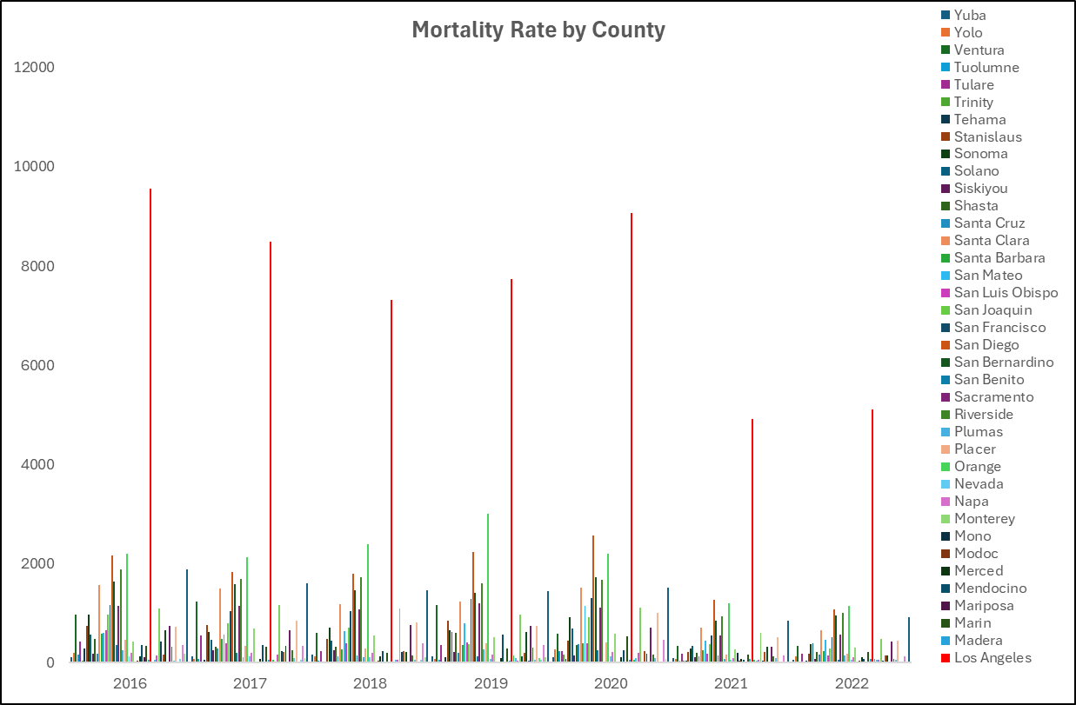

Despite heart failure had been the most common conditions within the observing period, the significant death rate was mostly caused by Acute Stroke and Pneumonia. The rate of death by heart failure seems not significant.

In particular, Acute Stroke Hemorrhagic and Acute Stroke Subarachnoid has been the most fatal condition in California from 2016. The Mortality Rate was at around 23% on case average.

**Whether more cases led to more death during these years?**

**This question arose when there is a theory that if more cases caused more death? In other words, Californian hospital can handle the increased number of cases? This analysis was conducted by Scatter Plot to investigate the relationship between the two variables, conditions/procedures and Number of Death. The result plot did not show any particular trend between these two variables, we can see that more cases didn’t lead to more death.**

**Hospital Ratings:**

The Rating variable includes four distinct values which are Better, As Expected, None, and Worse. In general, Californian hospital were rated “As Expected” quality from 2016 to 2022. However, the “As Expected” rating reduced by almost half in 2021 and 2022 compared to the previous years.

**Bonus analysis:**

In this analysis, I filter the top ten hospitals with the highest number of “Better” Rating, to get to the conclusion that Centinela Hospital Medical Center had been the best hospital in the investigating period.

Likewise, by using the same method but listing the top ten hospital with lowest rating, demonstrate “Worse” quality, I came up with the finding that Mercy Medical Center Redding and Antelope Valley Hospital are the worst rated hospital with the same number of 43 worse ratings.

**Analysis conclusions:**

This analysis emphasizes that California hospitals amazed us on how they can reduce cases and death rates since 2020. Most of death rates were due to acute conditions such as Stroke and Pneumonia, not dues to chronic condition. It can be seen that, they had handled treatable health conditions very well. In overall, most of California have met the inpatient care expectation by good ratings.

If possible, I expect to see the continuous data for the year of 2023 and 2024 to see if they could reduce the death rate by acute diseases and keep chronic death lower to see how well they can perform. This may be another continuing analysis for these two years later.

I really appreciate your time spending on this article, and please don’t hesitate to reach out if should you have any questions or contributions.

And please feel free to connect with me on LinkedIn via this link: